VIETNAM NATIONAL UNIVERSITY OF HOCHIMINH CITY

THE INTERNATIONAL UNIVERSITY

SCHOOL OF COMPUTER SCIENCE AND ENGINEERING

Ho Chi Minh City, Vietnam

2023

**SPECIAL STUDY OF THE FIELD**

PRE-THESIS REPORT

Online Library Management System

By

**Thai Gia Lac** – ITITIU19152

Advisor: **Mrs. Huynh Kha Tu**

**Table of Contents**

CHAPTER 1: INTRODUCTION AND GOALS3

1.1 Background3

1.2 Motivation3

1.3 Goals of project3

CHAPTER 2: PLANNING THE PROJECT5

2.1 Student functions5

2.2 Admin functions6

CHAPTER 3: GOAL ATTAINMENT7

3.1 Function interface design student 7

3.2 Function interface design admin14

3.3 Compare with original project requirements18

CHAPTER 4: PROJECT PLANNING FUTURES27

4.1 Compare with original project requirements27

4.2 Compare with original project requirements28

**Table of Figures**

Figures 1: Form to navigate student to routes register 7

Figures 2: Form request account 8

Figures 3: Login form 8

Figures 4: Display home for student9

Figures 5: Display library for student9

Figures 6: Display book library and searching10

Figures 7: Borrow book page11

Figures 8: Cart page12

Figures 9: History page12

Figures 10: Update profile page13

Figures 11: Notification page14

Figures 12: Manage library page15

Figures 13: Manage students page15

Figures 14: Create students page16

Figures 15: Manage order page17

Figures 16: Create new book page17

**CHAPTER 1: Introduction and goals**

It is only natural that even age-old customs like going to the library have changed in today's fast-paced world when technology has revolutionized nearly every aspect of our lives. We are excited to announce our online library management website, which aims to provide students with convenience and effectiveness. By removing the requirement for students to physically visit a traditional library, our platform transforms how they borrow books while also saving them time and effort.

* 1. **Background:**

Our online library management system is made to meet the requirements of contemporary students who want a simpler and more convenient approach to borrow books. Traditional libraries frequently have issues, including short hours, protracted lines, and the bother of physically looking for books. These challenges are eliminated by using our website.

* 1. **Motivation:**

Our motivation behind developing this online library management system stems from our desire to enhance the learning experience for students. We understand that students lead busy lives and have multiple commitments. By providing a platform that allows them to conveniently access and borrow books online, we aim to support their educational journey and foster a love for reading.

* 1. **Goals of project:**
* **Improve Accessibility: T**he main objective of this project is to give students quick, simple access to a variety of books without requiring them to go to a real library. We want to encourage pupils to read and learn by putting the library at their fingertips.
* **Save Time and Effort:** By removing the need for students to physically browse bookshelves, we hope to save them important time and effort. Students may rapidly browse and search for books using our online library management system, as well as check their availability and make reservations from the convenience of their own devices.
* **Streamline Book Borrowing Process:** Another important goal of this project is to streamline the entire book borrowing process. By implementing features such as a cart system, students can easily manage their book selections and complete the booking process smoothly. The system will also provide information on the deadline to return books, ensuring timely returns and minimizing late fees.
* **Efficient Inventory Management:** The project aims to provide administrators with an intuitive admin panel to manage the library's inventory effectively. Administrators will have the ability to add new books, update existing ones, and remove outdated or damaged books from the system. This feature will ensure accurate and up-to-date information about available books for students.
* **Promote Communication and Support:** The project includes a chat support tool in an effort to improve communication between students and administrators. Students will be able to contact administrators without difficulty for help or explanation regarding the availability of books, the borrowing policies, or any other questions they may have. A smooth borrowing experience will be made possible via effective communication.
* **Promote Reading Culture:** Ultimately, this project aims to foster a reading culture among students. By providing a user-friendly and accessible platform for borrowing books, we strive to encourage students to engage in reading and expand their knowledge base. The project aims to contribute to the intellectual growth and academic success of students.
* **Continuous Improvement and Adaptability:** In the long run, we want this project to be a dynamic system that can adjust to shifting user requirements and technology improvements. In order to maintain the platform as a useful tool for students, we will proactively solicit user feedback and make ongoing platform improvements in response to their suggestions.

**CHAPTER 2: Planning the project**

* 1. **Student functions:**
* **User Registration:** Students will have the ability to create an account on the online library management website by providing necessary information such as their name, email address, and student ID in form request if they don’t have account . This form will be sent to admin side to help creating account and after all information for this sent through email for student.
* **User Login:** Students who log in to the website with an account with student authority will go to the library interface and limit the functions allowed to students only.
* **Book Search and Browse:** Students can search for books by title, author, genre, or keywords. They can browse through the available books in the online library and view detailed information about each book, including a summary, author information, and availability status.
* **Book Reservation:** Students can reserve books online by adding them to their cart or booking them directly. They can select the desired pick-up date and duration for borrowing the book.
* **Cart Management:** Students can manage their book selections in the cart, add or remove books, and modify the borrowing details such as the pick-up date and duration. The cart will display the total number of books, due dates, and any applicable late fees.
* **Borrowing History:** Students can access their borrowing history, which includes a list of books they have borrowed in the past, along with the dates of borrowing and return.
* **Book Renewal:** If students require additional time to read a book, they can request a renewal of the borrowing period through the online system, subject to availability and any applicable rules set by the library.
* **Communication with Admin:** Students can utilize the chat support feature to communicate directly with the administrator or library staff for inquiries, assistance, or clarification regarding book availability, borrowing rules, and any other related matters.
* **Book Return:** Students can view the deadline for returning borrowed books and make sure to return them on time to avoid late fees. They can also receive reminders or notifications about upcoming due dates.
* **Personal Profile Management:** Students can update their personal information, such as contact details or address, through their user profile. They may also have the option to provide feedback or suggestions regarding the online library management system.

**2.2 Admin functions:**

* **Admin Registration:** Admins can register by filling out a registration form similar to students but with the option to select the "admin" role. The form will require necessary information such as name, email address, and admin ID.
* **Admin Login:** Admins can log in to the system using their credentials. Upon login, they will have access to additional functions and features specifically designed for administrators.
* **Book Library Management:** Admins have the authority to manage the library's book inventory. They can add new books to the system by entering book details such as title, author, genre, and availability status. They can also update existing book information or remove books from the library if necessary.
* **User Account Management:** Admins can create user accounts for students, enabling them to access the online library system. They will be responsible for inputting student details such as name, email address, and student ID into the system.
* **Chat with Students:** Admins can engage in real-time communication with students through the chat support feature. They can provide assistance, answer queries, or address concerns related to book availability, borrowing rules, or any other relevant matters.
* **Order Management:** Admins can manage and track book reservations and borrowing requests made by students. They can view the status of each order, approve or reject requests, and update the system accordingly.
* **Create New Product:** Admins may have the authority to create new product listings, such as special collections or featured books, to showcase on the website. This feature allows admins to highlight specific books or promotions to attract student attention.
* **Update Personal Information:** Admins have the ability to update their personal information, such as contact details or address, through their admin profile. This ensures accurate and up-to-date admin data within the system.
* **Notifications:** Admins will receive notifications when student requests are submitted and require approval. This feature keeps admins informed of new requests and allows them to take appropriate actions promptly.

**CHAPTER 3: Goal attainment**

* 1. **Function interface design student:**
* **Student registration:**



**Figure 1:** **Form to navigate student to routes register**

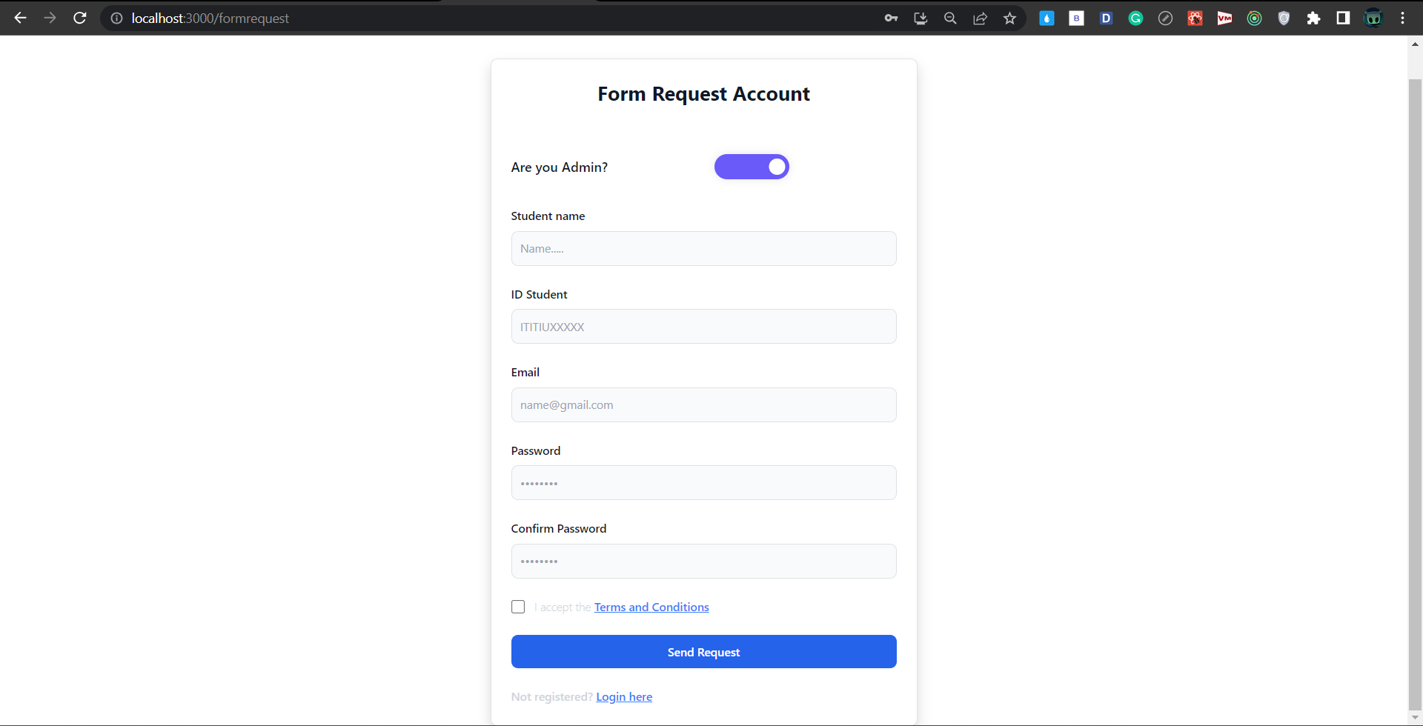

**Figure 2: Form request account**

* Complete the registration form interface and send a request to the admin to create an account, but the function is still **fixing the error**
* **Student login:**

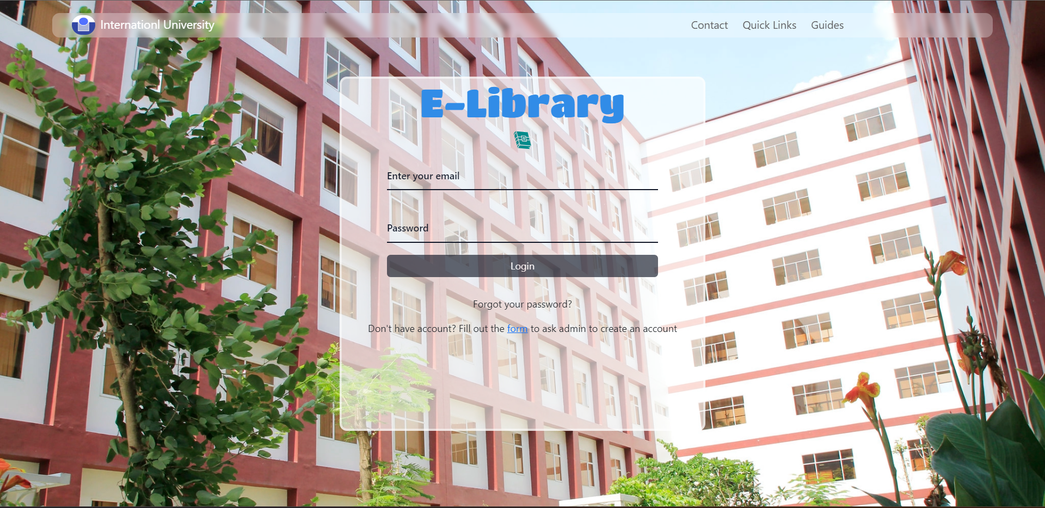

**Figure 3: Login form**

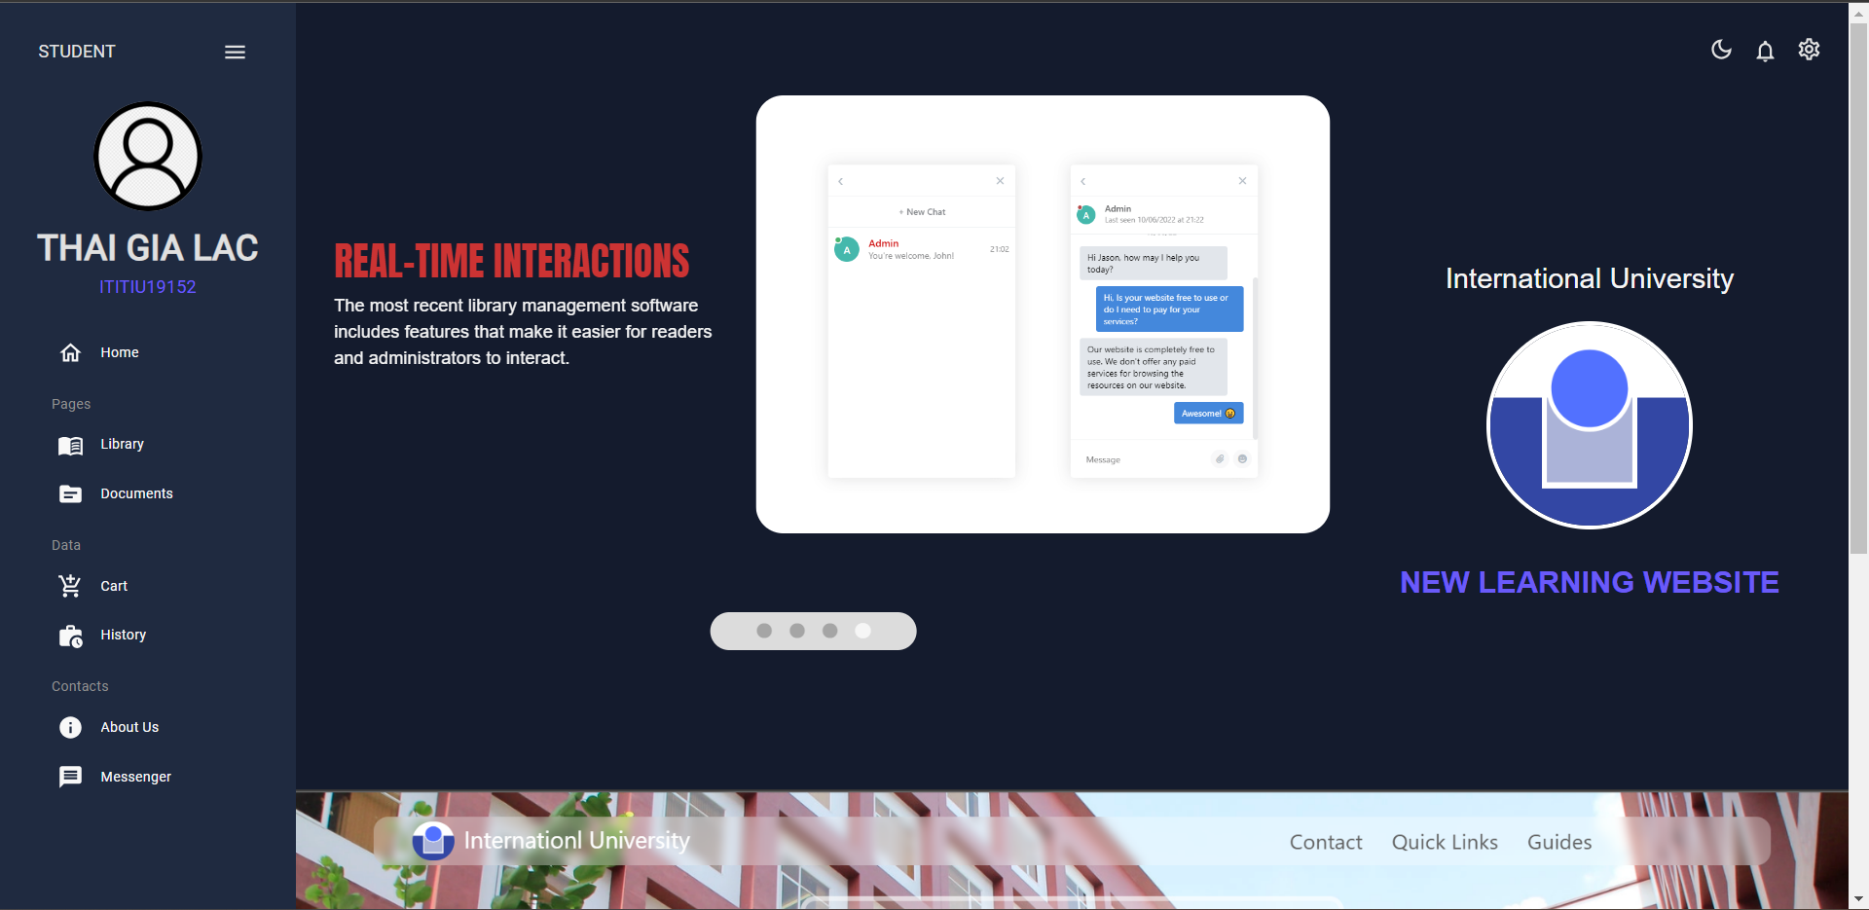

**Figure 4: Display home for student**

* After completing the **login** and account validation interface on both the student and admin sides **(Figure 3),** after successful login, you will go to the student **home page (Figure 4).**
* **Book Search and Browse:**

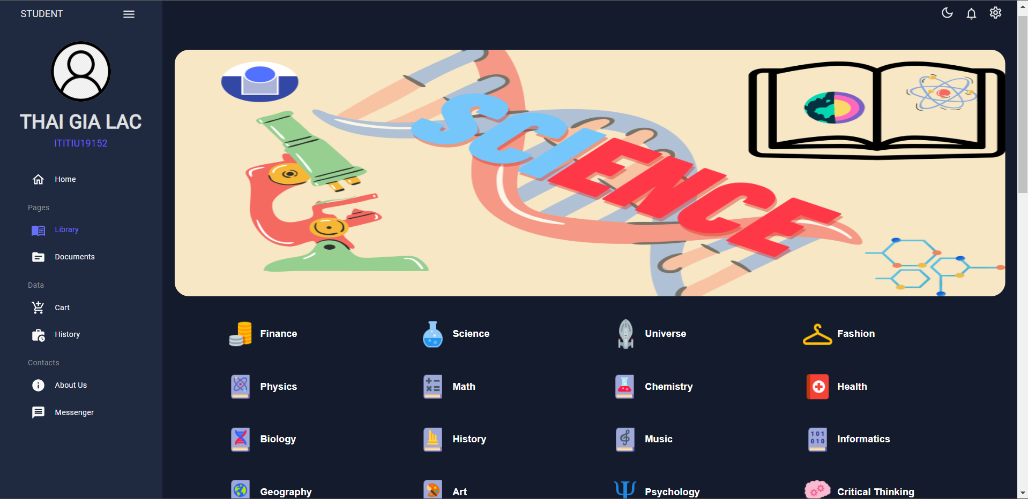

**Figure 5: Display library for student**

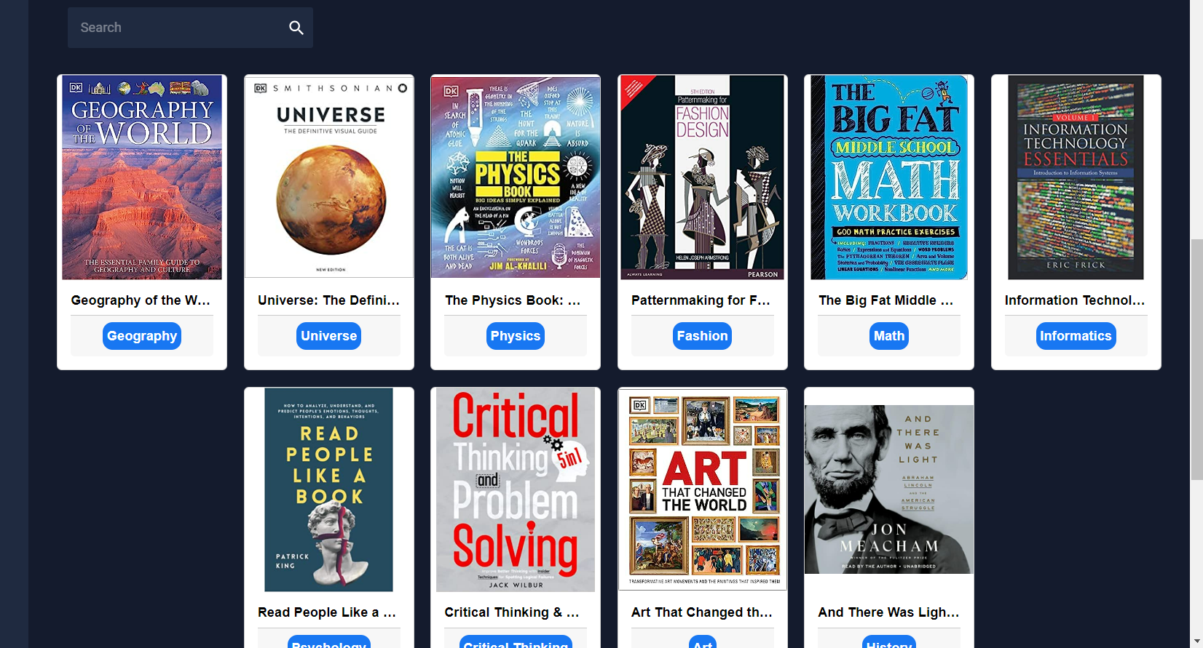

**Figure 6: Display book library and searching**

* Students select the library item on the left side of the dashboard to go to the book **library page ( Figure 5 )**
* The library interface will list a lot of book dialogues for students, the student can **filter categories or search books ( Figure 6 )** easily to find the book that they want
* **Book Reservation:**

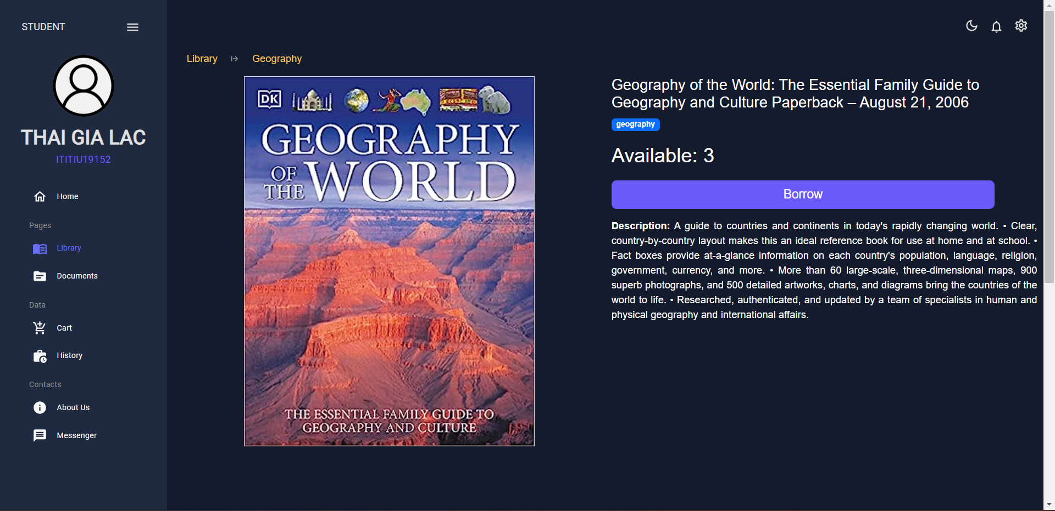

**Figure 7: Borrow book page**

* When a student chooses any book it navigates the student to a detailed book and the student can read the whole information of that book, then click the button borrow to add the text to the order page **( Figure 7 )**
* A book including the **title**, the **genre** of the book, the number of **books available** for students to order, and finally a **description** that summarizes all the details of the book **( Figure 7 )**
* **Cart Management:**

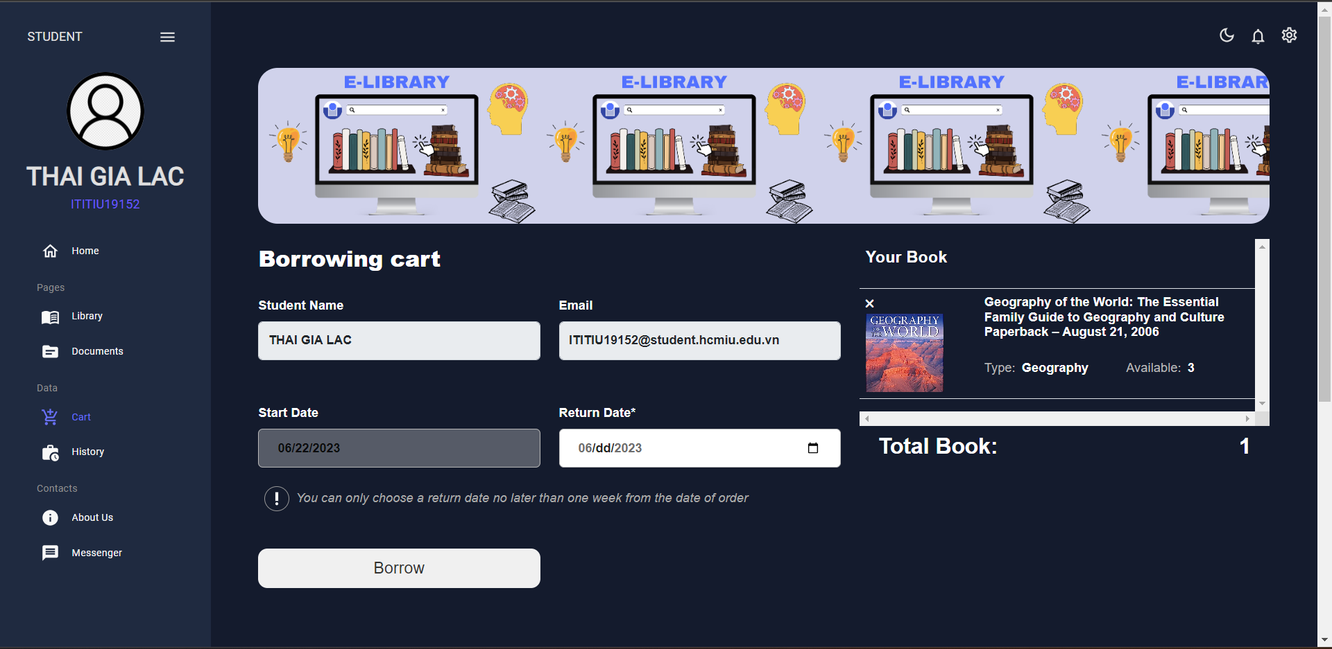

**Figure 8: Cart page**

* **Borrowing History:**

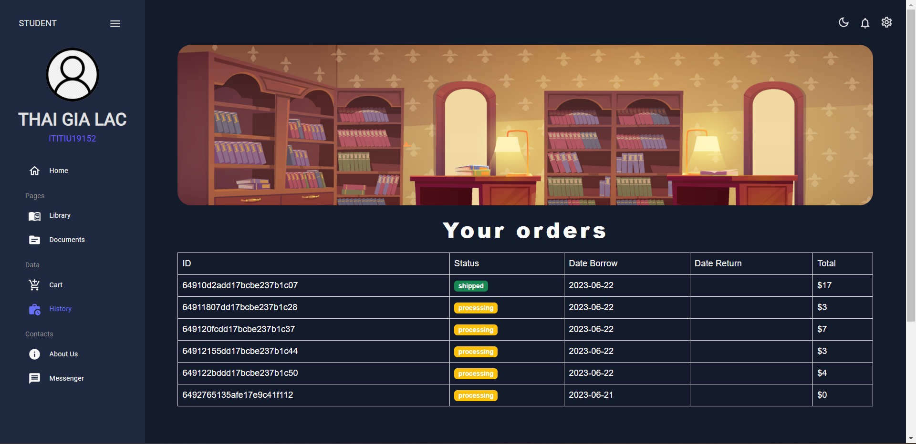

**Figure 9: History page**

* **Book Renewal:**

Not yet function for student allow to renew book

* **Communication with Admin:**

- Done with interface Student , student just only show and chat with admin when they need to support, but the function still have some error and can implement.

* **Book Return:**

- There is no section when the student returns the book, the admin will record the return of the book and will be notified on that student's account

* **Personal Profile Management:**

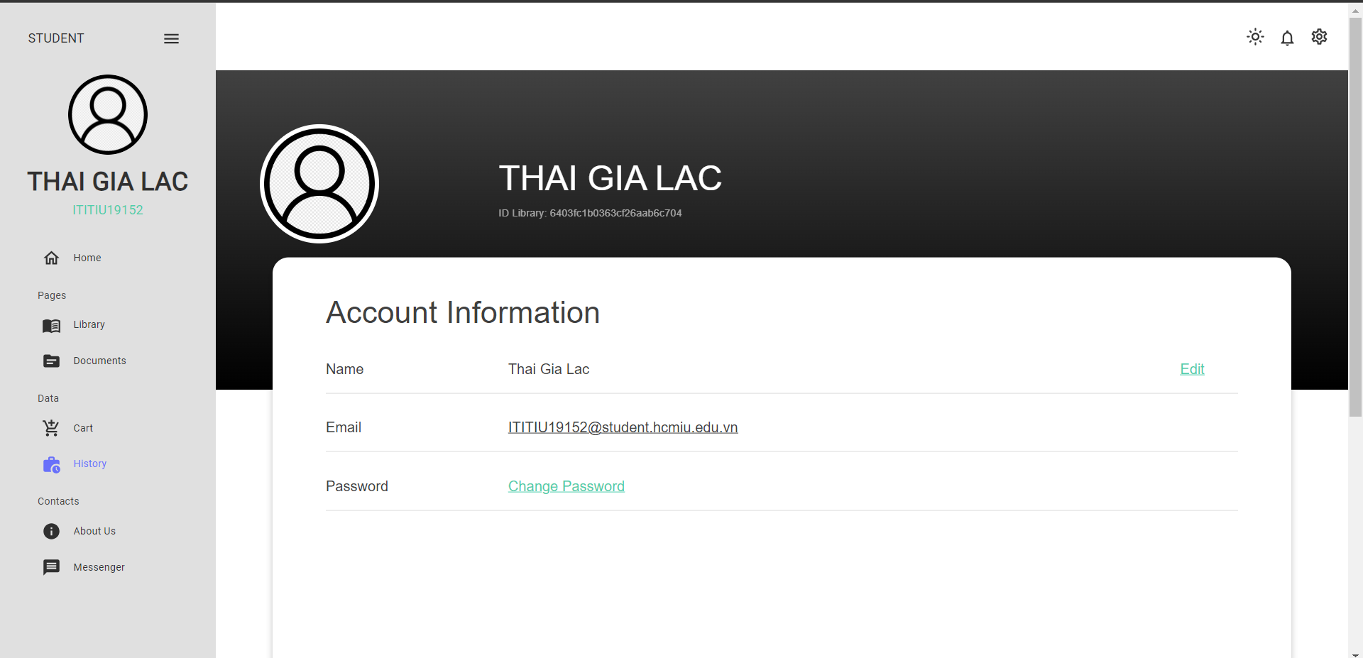

**Figure 10: Update profile page**

* **Notifications:**

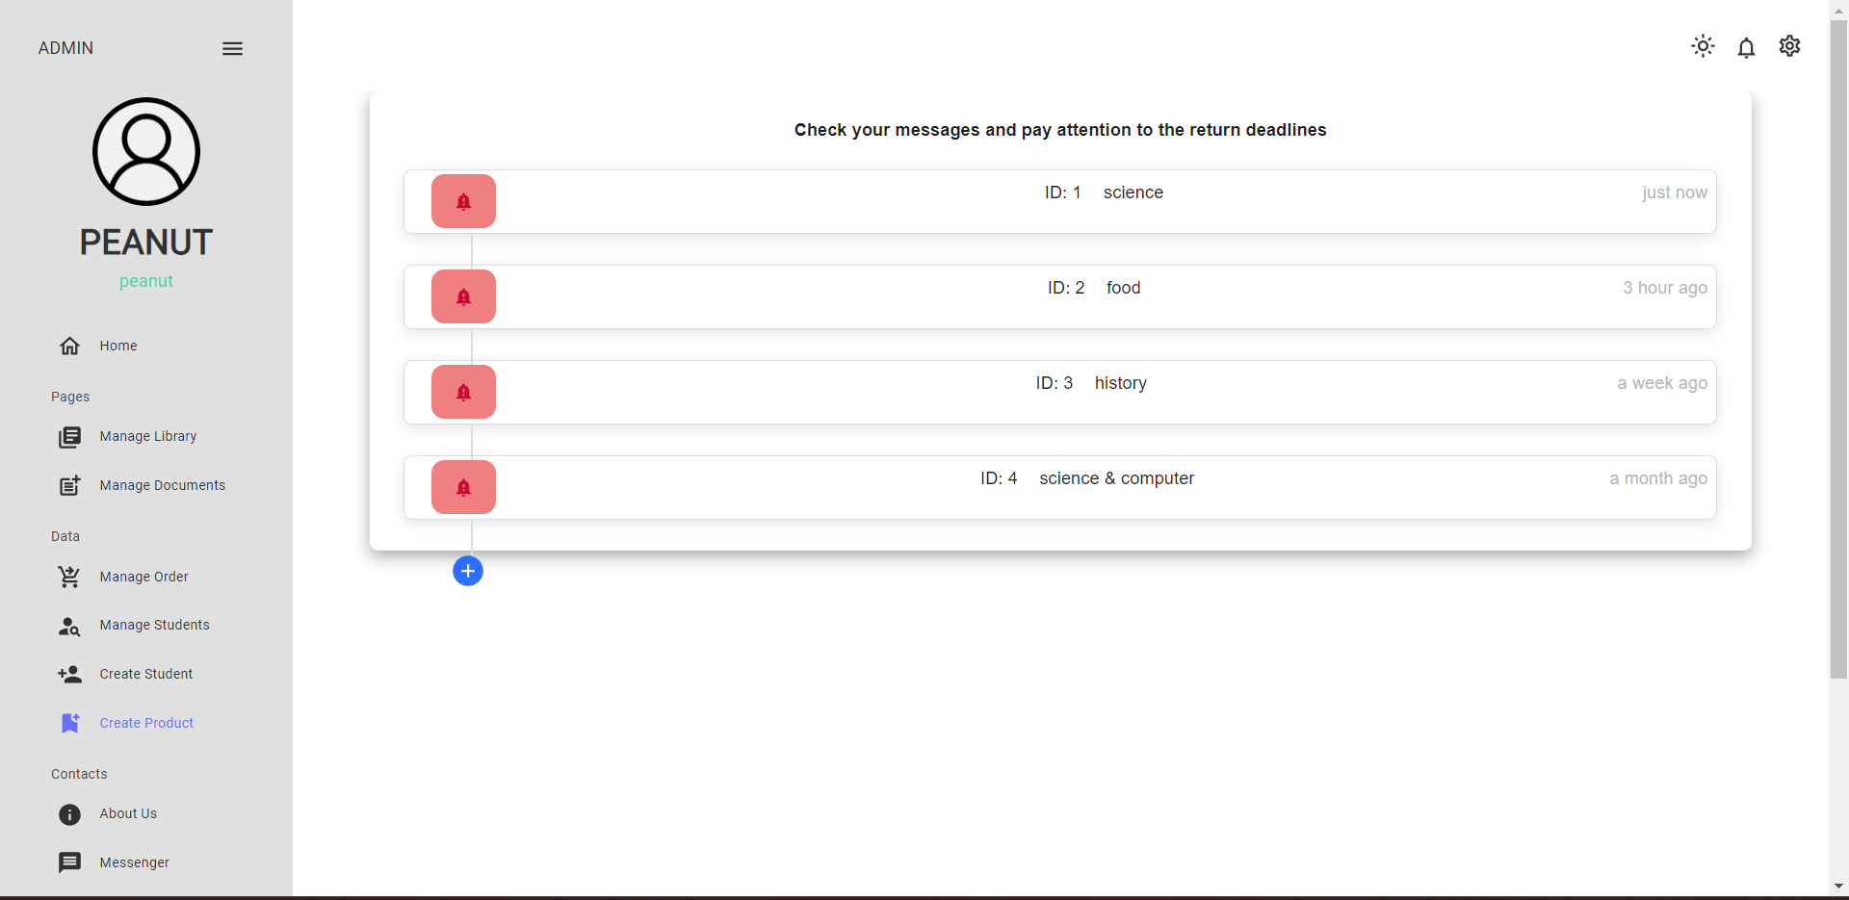

**Figure 11: Notification page**

* 1. **Function interface design admin:**
* **Admin Registration & Login:**  The same display with role students
* The admin login interface is similar to the student role, but when that account is authorized as admin, when logging in, there will be a dashboard interface with management functions.
* When the admin registers for an account, they also fill out the same form as the student, but they will choose the admin role to let the admin create the right position.
* **Book Library Management:**

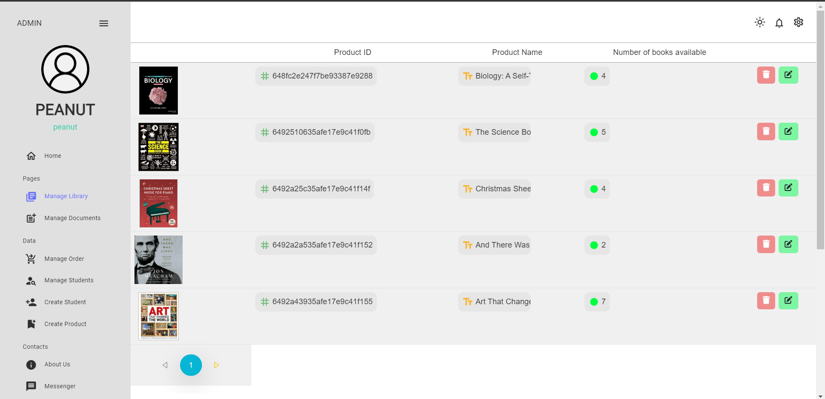

**Figure 12: Manage library page**

* On the library management page, the admin will see all the books in the database, the available quantity of each book. Admin has the function to edit books or remove books
* **User Account Management:**

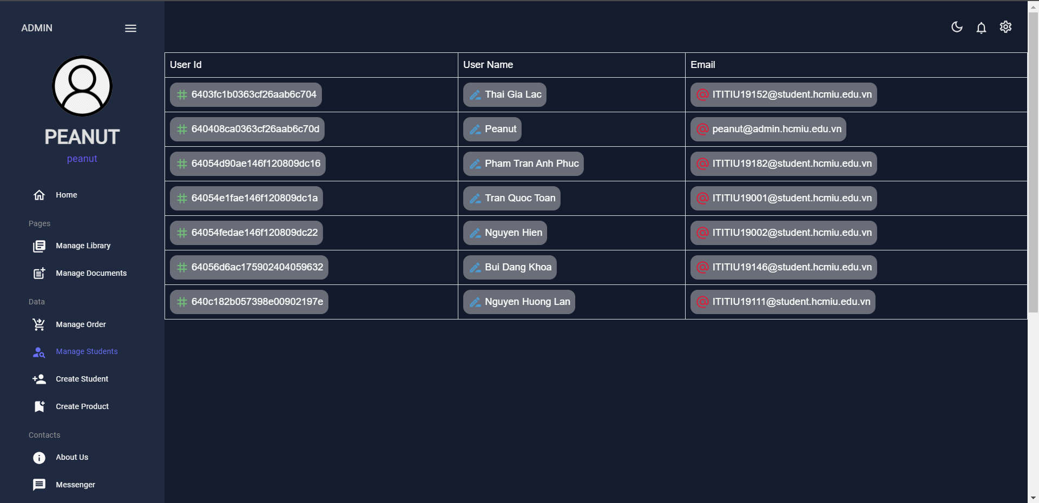

**Figure 13: Manage students page**

* Admin can view and manage all students, each student shown in the table in route manage student has student id, student name and email
* **Create account for Students:**

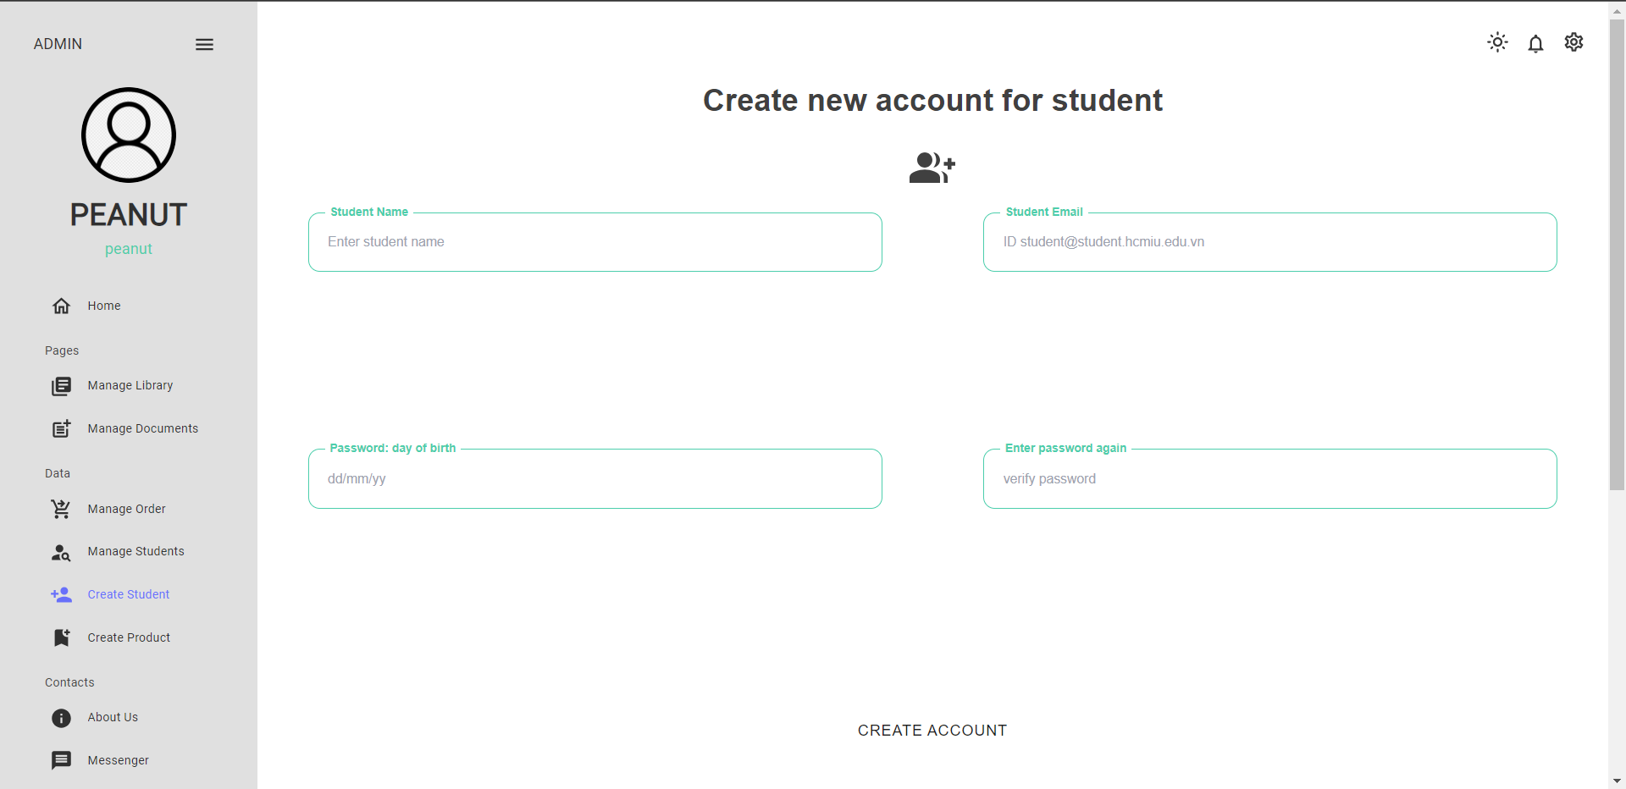

**Figure 14: Create students page**

* The admin may have the right to create an account for students, but currently there is no email notification function that students use to fill out the registration form with all account information for students to log in.
* **Order Management:**

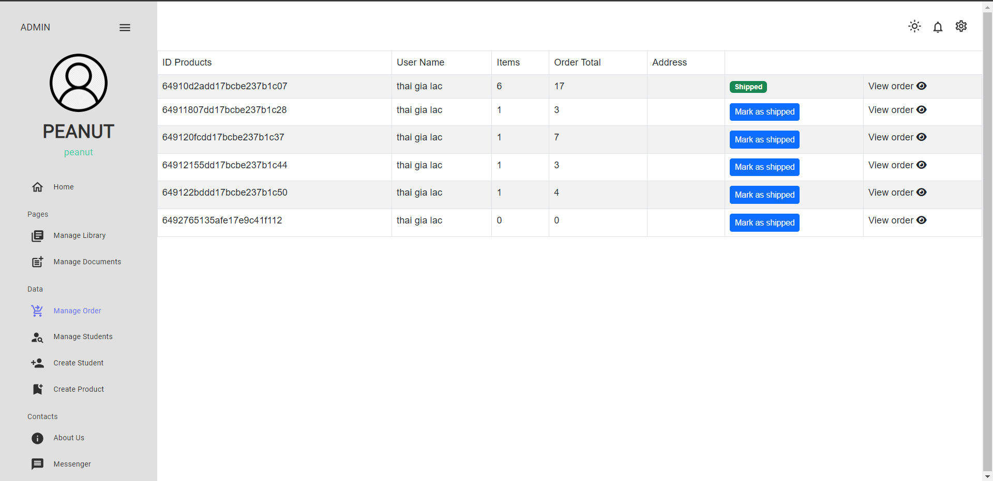

**Figure 15: Manage order page**

* **Create New Book:**

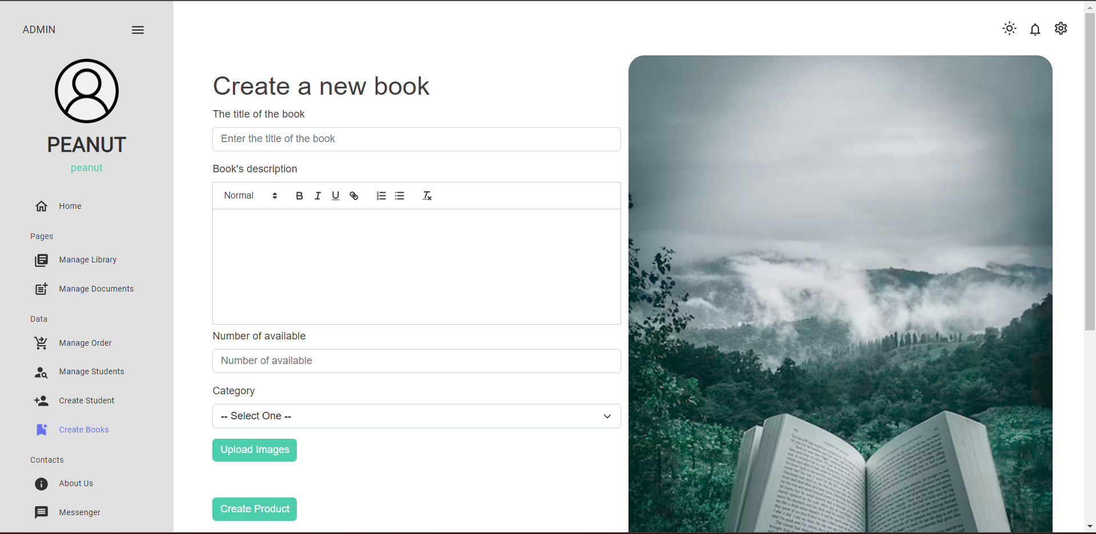

**Figure 16: Create new book page**

* Admin selects the create book item on the side bar to go to the page to create a new book, on this page admin creates a new book by entering the book title, the book description can be pen-source text editor based on WYSIWYG. We can make full customizations on the various features in the toolbar that we will make in the react quill text editor. It has various props such as themes, value, defaultValue, placeholder, and id. enter the number of available books and upload unlimited book covers by cloudinary and finally click create book to create the book into the database
* **Update Personal Information:**
* The same display with role students
* **Notifications:**
* The same display with role students
* **Communication**

- Done with interface Admin can show all of student and admin to chat. But the function still have error and can implement.

* 1. **Compare with original project requirement:**

|  |  |  |
| --- | --- | --- |
|  | **Initial requirements of the project** | **Achieved results of the process** |
| Background and goals | - The online library website will help IU students order books directly on the site and receive books at the library on IU university library. The website will make it easier for students to find books by major and more resources are better managed, students will know what books are available to borrow and the loan and return time of each book. |   - Completed building a user-friendly online library management interface for students to borrow books and the admin side did not take much time to manage all data.  - Completing the interface for both student and admin sides, user functions have been planned and are still in progress to implement this online library system. |
| Models of database | **1. User** ( name, email, password, avatar, role, cart, notification, orders )  **2. Book** ( title, description, availability, category, pictures )  **3. Order** ( book, owner, status, total, date, dueDate )  **4. Message** ( message, user, sender )  **5. Chat** ( member ) | - have fully built back end databases and the functions have also been tested through postman and mongoDB with success.      - The book database is still in use and gets information from Amazon.com |
| Page & Function of student role: | **1. Login Page** | Complete the interface and function entering (verified account) |
| **2. DashBoard ( student )** | complete the student dashboard page  Sidebar:  Topbar:    - There is a button to adjust the dark mode vs light mode has completed the function part  - Notification icon to go to the notification page  - Setting icon to show toolbar including update profile and log out |
| **3. Home Page** | Content each Routes:      - The home page has completed almost the entire interface including 3 sections  + section 1: banners on book topics  + section 2: icons equivalent to book genre items  + section 3: search bar and all books (limited to 10 books per pagination) |
| **4. Book Page** | - Complete the Book page with a cover image of unlimited book rights on the left, information such as title, number of books available, borrow button, categories and description on the right.  -Below is a section similar to the book that shows books of the same genre in the above book. |
| **5. Order Book Page** | Ảnh có chứa văn bản, ảnh chụp màn hình, phần mềm, Phần mềm đa phương tiện  Description automatically generated  - Done with display order book page , when student borrow a book and it will be added immediately in this route . This page get information of student ( name, email ) and set up day start borrow book is current day and student can choose day they want to return book ( deadline is one week ) |
| **6. History Order Book Page** | - Complete with the history order book page , When students confirm to borrow books at the order book page, they will be redirected to this page to wait for the admin to approve the book. Students can view the entire history of borrowed information (borrowed date, return date, amount ). |
| **7. About Us** | - Relatively finished about the interface |
| **8. Chat with Admin Page** | - Finished the interface but the function is still faulty and not working |
| Page and Functions of the Admin role: | **1. Login Page** | - Done with display and function login admin ( same with student ) |
| **2. Dashboard ( admin )** | -  - Complete the interface for admin dashboard  - Admin has different function for student in dashboard |
| **3. Home Page** | - The same display with student side |
| **4. Create a Book Page** | - Complete interface create book, admin can create by fill title, description , number of available , category, and upload image by cloudinary |
| **5. Create a student account page** | - Complete interface page create account for student, and admin can create account for student but the all of detail can not submit through email for student login ( this function still update ) |
| **6. Manage order book page** | - Completing the manage order book interface, the admin can confirm the student's book loan application from "confirm" to "accepted", then the student can know and come to receive the book directly from the library (but this function is still not available and under development). |
| **7. Update the book page** | - Complete admin function can customize the information of each book |
| **8. Manage book page** | - Admin can manage all of book in database, done with function update book and remove book |
| **9. Chat with admin and student** | - Same status with student , have many error and still fixing  - Done with interface |

**CHAPTER 4: Project planning futures:**

* 1. **Project completion:**
* **Registration**: The function of sending user registration request to admin by filling out the form is not yet completed, after completing the form, the user will send a request to the admin through the admin's notification page, the admin can see the information. and create an account, the information of that account will be sent all via the email that the user used to register.
* **Chat:** Complete the feature of students chatting with the admin and receiving notifications when there are new messages, the admin side can chat with both other admins and all students
* **Notification:** Complete the admin notice when receiving a registration request from the user, and notify when students send a request to borrow a book. Notifications when the admin confirms the student's order and informs the student about the successful loan application
* **Order History:** Complete student loan history, record return date and total number of books. After being accepted from the admin, you will receive a message to receive the book and in the history section, you can track the return deadline.
  1. **Future feature development and optimization:**
* Problem solving feature when a large number of users log in the website
* Responsive website to fit and compatible with all screen devices
* Update the feature of book renewal and book return.
* Updated jwt to refresh the token user , When the client accesses the interface that requires authentication, it will bring the Token with it. If the Token has not expired, the server will return the data that the client needs after authentication.
* Update profile: user can save change information about name, password and avatar image.
* Features remove student and penalties according to the laws when the return of books is overdue.